DISPOSAL OF GOODS BY TENDER

REQUEST
Disposal of Farm equipment – FORKLIFT at WA College of agriculture cunderdin
Site Address: WA College of Agriculture, 267 Baxter Road, Cunderdin, 6407
TECHNICAL ENQUIRIES: Daniel de Beer 0407476414
CONTRACTUAL ENQUIRIES: Yvonne Bopp (08) 96352100

LODGEMENT OF OFFERS
Offers must be completed in full and deposited into the tender box at the above address on the 6 September 2024 or emailed to Daniel.debeer@education.wa.edu.au or Yvonne.bopp@education.wa.edu.au before the 6 September 2024.
Completed offers must be received by:
CLOSING DATE: Friday 6 September 2024
CLOSING TIME: 3:00 pm
Offers lodged after the stipulated Closing Date and Time will be deemed late and will be excluded from consideration.
Please note that the tender box at the above address and Farm Workshop is only available on the 6 September 2024 and therefore please email any offers before the 6 September 2024 to Daniel.debeer@education.wa.edu.au or Yvonne.bopp@education.wa.edu.au .

CONTRACT REQUIREMENT
This Contract specifies the Department of Education’s requirement for the disposal of Farm Equipment at WA College of Agriculture Cunderdin.

The items:
ITEM NO. | DESCRIPTION
001 | Walk behind hydraulic forklift  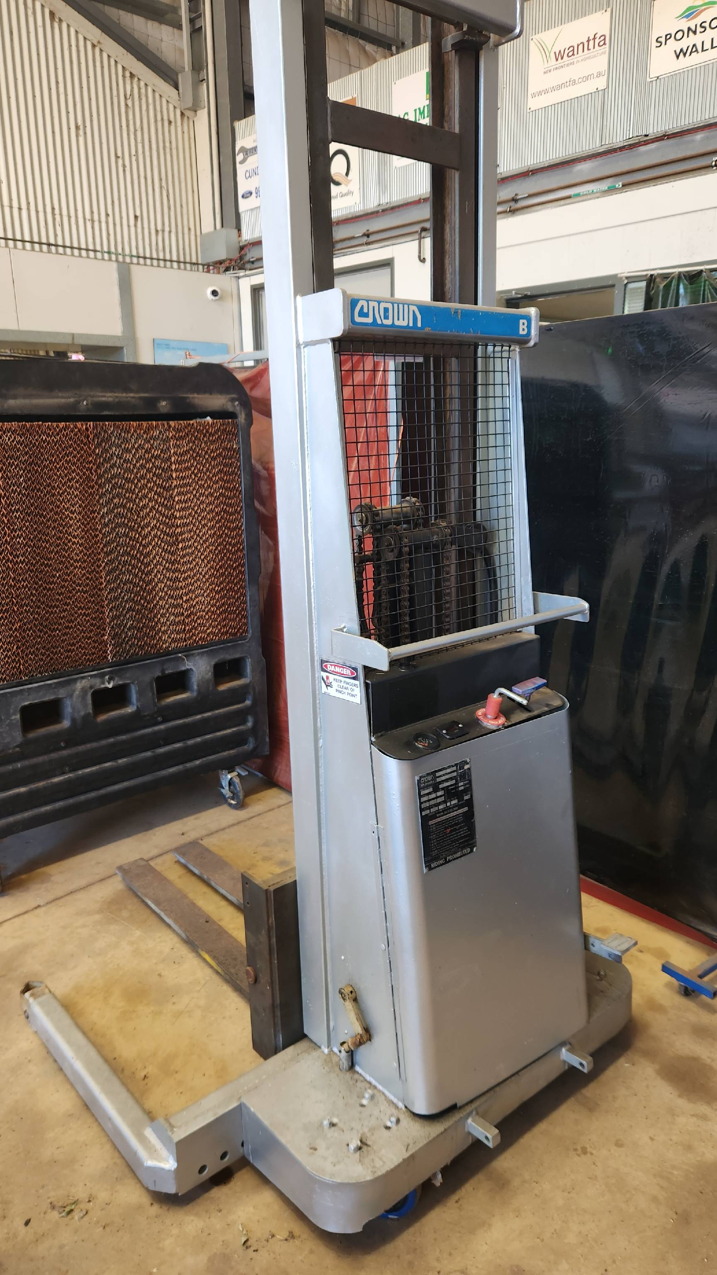

NOTE: Available for inspection by contacting Daniel de Beer on 0407476414 during business hours.
All items are located at: WA College of Agriculture Cunderdin, 267 Baxter Road, Cunderdin, 6407.
CONDITIONS OF DISPOSAL
BASIS OF OFFER FOR SALE
The above items are offered for sale on an “as is, where is” basis with all faults (if any). The Department of Education does not warrant the quality, quantity description or fitness for purpose of the items and will not be liable for any loss or damage whatsoever which the Purchaser may sustain owing to or in any way arising out of the quantity or quality of the materials, their use in operation, any error in the description of the same, or otherwise howsoever.
LIABILITY
- The Department of Education will not admit any claims on the grounds of defective goods, incorrect description, or error in quantity.
- The Purchaser acknowledges that in entering into the Contract that it is not relied on any promise, representation, warranty, or undertaking given by or on behalf of the Department of Education in respect to the suitability, quality, or condition of the goods and that the terms of the Contract comprise the whole of the agreement between the parties and that it is expressly agreed that no further conditions are to be implied into the Contract.
- It is the responsibility of the prospective purchasers to examine the items prior to submitting their Offer.
INSPECTION OF THE ITEMS
- An inspection of the items is recommended prior to submitting a bid;
- Inspection can be arranged by contacting Daniel de Beer on 08 96352100 or 0407476414 during business hours;
- Access to the site is not permitted without having first contacted the abovementioned contact; and
- The items are located at the WA College of Agriculture Cunderdin, 267 Baxter Road, Cunderdin, 6407.
ACCEPTANCE OF OFFERS
The Director General, Department of Education is not bound to accept the highest price offered and reserves the right to reject any or all offers submitted.
PAYMENT METHOD
Payment in full is required prior to the removal of the items. Payments can be made at the front office at the WA College of Agriculture Cunderdin.
The Successful Purchaser is responsible for all transfer and registration costs.
REMOVAL OF ITEMS BY SUCCESSFUL PURCHASER
The Successful Purchaser must remove the item(s) within fourteen (14) working days of being granted access to the site where the items are located.
Prior to removal, the Successful Purchaser must contact Daniel de Beer on 08 96352100 or 0407476414, to arrange site access and removal of the item(s) at a time and in a manner suitable.
Once the item(s) have been removed, the site must be left in a suitable and reasonable condition (clear, with all debris removed), to the satisfaction of the Department of Education.
PURCHASER RESPONSIBILITY
The successful purchaser when removing any item:
- Must ensure that safety measures are taken;
- Removal is at the expense of the successful purchaser; and
- Will be liable for any damage incurred in the removal.
DEPARTMENT RESPONSIBILITY
The Department of Education will ensure access to the site and the item(s) prior to removal by the Purchaser.
OFFERS
Offers are to be submitted on the attached price schedule (refer Part B) and delivered to the email addresses as indicated on the cover page.
No erasure will be allowed on the offer. If an alteration is necessary, it must be in ink and initialled by the bidder.
The purchaser must not make any alteration, qualification, or addition intended to negate or modify the conditions of this offer. Failure to observe the foregoing will render such offers liable to rejection as informal.
LATE OFFERS
Late offers will not be accepted.
Any offers lodged after 4.00 PM on the day nominated in the Disposal document (refer cover page) will be classified as a late offer.
OFFER TO PURCHASE
Please complete, sign and return this offer to the address detailed on the front page.
Disposal by Tender – Disposal of Farm Equipment - Forklift at the WA College of Agriculture Cunderdin.
I / We the undersigned offer to purchase the items as listed below from the Department of Education in accordance with the terms and conditions set out herein under Disposal by Sale.

CONTACT NAME:
COMPANY NAME:
ABN NUMBER:
ADDRESS:
TELEPHONE:
FACSIMILE:
MOBILE PHONE:
E-MAIL:
SIGNATURE:
DATE:
Please note that the tender box at the above address and Farm Workshop is only available on the 6 September 2024 and therefore please email any offers before the 6 September 2024 to Daniel.debeer@education.wa.edu.au or Yvonne.bopp@education.wa.edu.au as this is the only point of registration for offers before Open day. Offers must be completed in full and lodged by 3:00pm on Friday 6 September 2024.

OFFER TO PURCHASE

Purchaser’s Name:
ITEM NO. | DESCRIPTION |  | PRICE (INC GST)
001 | Walk behind hydraulic forklift |  | $
TOTAL PRICE OFFERED: |  |  | $

